QUESTION 1:

Create a simple Java application that simulates a basic calculator. The calculator should be able

to perform addition, subtraction, multiplication, and division operations based on user input.

SOURCE CODE :

import java.util.Scanner;

public class calculator {

public static void main(String[] args) {

Scanner scanner = new Scanner(System.in);

System.out.println("Choose an operation:");

System.out.println("1. Addition");

System.out.println("2. Subtraction");

System.out.println("3. Multiplication");

System.out.println("4. Division");

System.out.println("5. Exit");

while(true){

System.out.print("Enter choice : ");

int choice = scanner.nextInt();

if (choice == 5) {

System.out.println("Exit..");

break;

}

System.out.print("Enter first number: ");

double num1 = scanner.nextDouble();

System.out.print("Enter second number: ");

double num2 = scanner.nextDouble();

double result;

switch (choice) {

case 1:

result = num1 + num2;

System.out.println("Result: " + result);

break;

case 2:

result = num1 - num2;

System.out.println("Result: " + result);

break;

case 3:

result = num1 \* num2;

System.out.println("Result: " + result);

break;

case 4:

if (num2 != 0) {

result = num1 / num2;

System.out.println("Result: " + result);

} else {

System.out.println("Error: Division by zero is not allowed.");

}

break;

default:

System.out.println("Invalid choice. Please choose a number between 1 and 5.");

}

}

scanner.close();

}

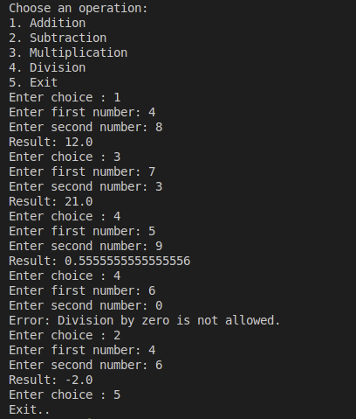

QUESTION 2 :

Create a Java program that calculates the grade based on marks entered by the user.

SOURCE CODE :

import java.util.Scanner;

public class grades {

public static void main(String[] args) {

Scanner sc = new Scanner(System.in);

boolean grade = true;

while (grade) {

System.out.println("Enter the Marks : ");

int marks = sc.nextInt();

sc.nextLine(); // Consume the newline character

if (marks >= 90) {

System.out.println("The student is graded A");

} else if (marks >= 80) {

System.out.println("The student is graded B");

} else if (marks >= 70) {

System.out.println("The student is graded C");

} else if (marks >= 60) {

System.out.println("The student is graded D");

} else if(marks>=50){

System.out.println("The student is graded E");

} else {

System.out.println("The student has Failed");

}

System.out.println("Do you want to check more grades? (y/n) : ");

String res = sc.nextLine().toLowerCase();

if (!res.equals("y")) {

grade = false;

}

}

System.out.println("Exit...");

sc.close();

}

}

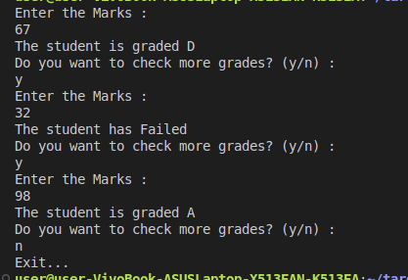

QUESTION 3 :

Write a Java program that demonstrates various OOP concepts including class design, inheritance, abstraction, polymorphism, encapsulation, method overriding, and method overloading.

SOURCE CODE :

public class abc{

public static void main(String[] args){

Shapes triangle = new Triangle();

Shapes square = new Square();

triangle.area();

square.area();

System.out.println("Triangle has " + triangle.getnumberofsides() + " sides.");

System.out.println("Square has " + square.getnumberofsides() + " sides.");

((Triangle) triangle).color();

((Triangle) triangle).color("black");

}

}

class Triangle extends Shapes{

public Triangle(){

setnumberofsides(3);

}

public void area(){

System.out.println("The Area of a Triangle is half of its Base x Height.");

}

public void color(){

System.out.println("Triangles may have different colors.");

}

public void color(String c){

System.out.println("This Triangle is " + c + " in color.");

}

}

class Square extends Shapes{

public Square(){

setnumberofsides(4);

}

public void area(){

System.out.println("The Area of a Square is 4 x length of its side.");

}

}

abstract class Shapes{

private int numberofsides;

public int getnumberofsides(){

return numberofsides;

}

public void setnumberofsides(int numberofsides){

this.numberofsides = numberofsides;

}

public abstract void area();

}

